**TASK** 1:

CODE:

**TASK 2**:

CODE:

OUTPUT:

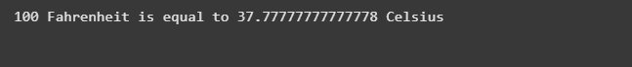

**TASK 3**:

CODE:

**TASK 4:**

**CODE:**

|  |  |
| --- | --- |
| **ZERO-SHOT** | **FEW-SHOT** |
|  |  |
| |  | | --- | | **Zero-shot Prompting:** The model is only given a task description. Relies only on internal knowledge and interpretation. |  |  | | --- | |  | | **Few-shot Prompting:** The model is given the same task **plus examples** of input/output. |

**TASK 5:**

**CODE AND OUTPUT:**

